Part D Q1. Explore Various Types of IPv6

Problem Statement
Explore and configure various types of IPv6 addresses including Global Unicast, Link-Local, and Multicast across multiple subnets.Configure router interfaces and PC default gateways, then verify IPv6 connectivity between devices within the same subnet and across different subnets using Cisco Packet Tracer.
OUTPUT & CONFIG:
Layout and Router configuration:
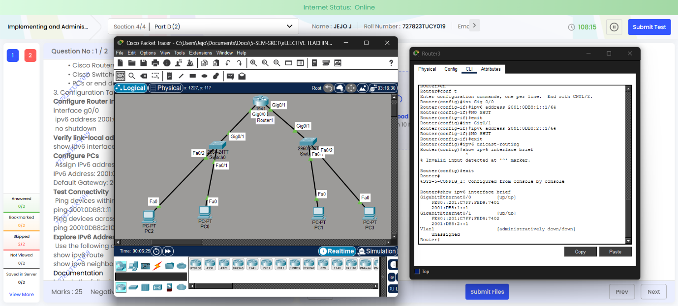
Router ipv6 route & neighbour commands:
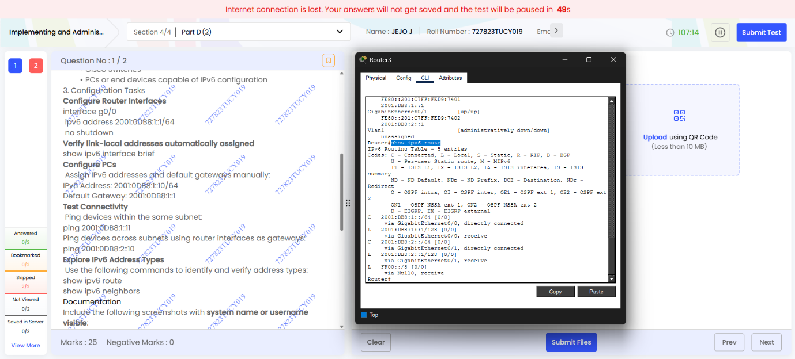
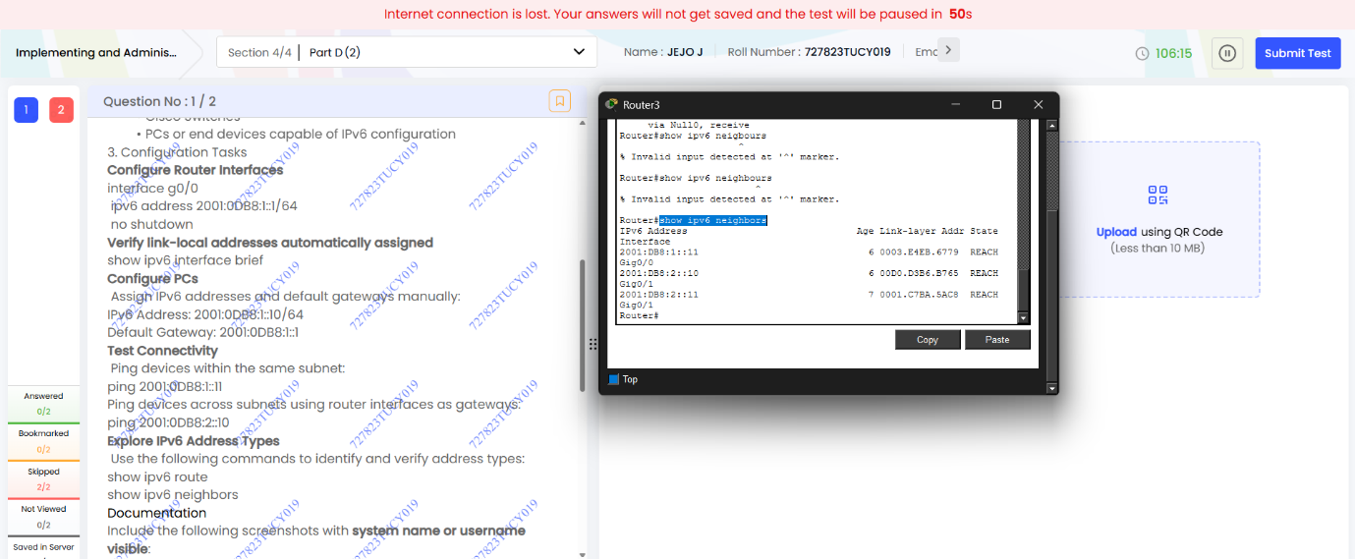
Ping results:
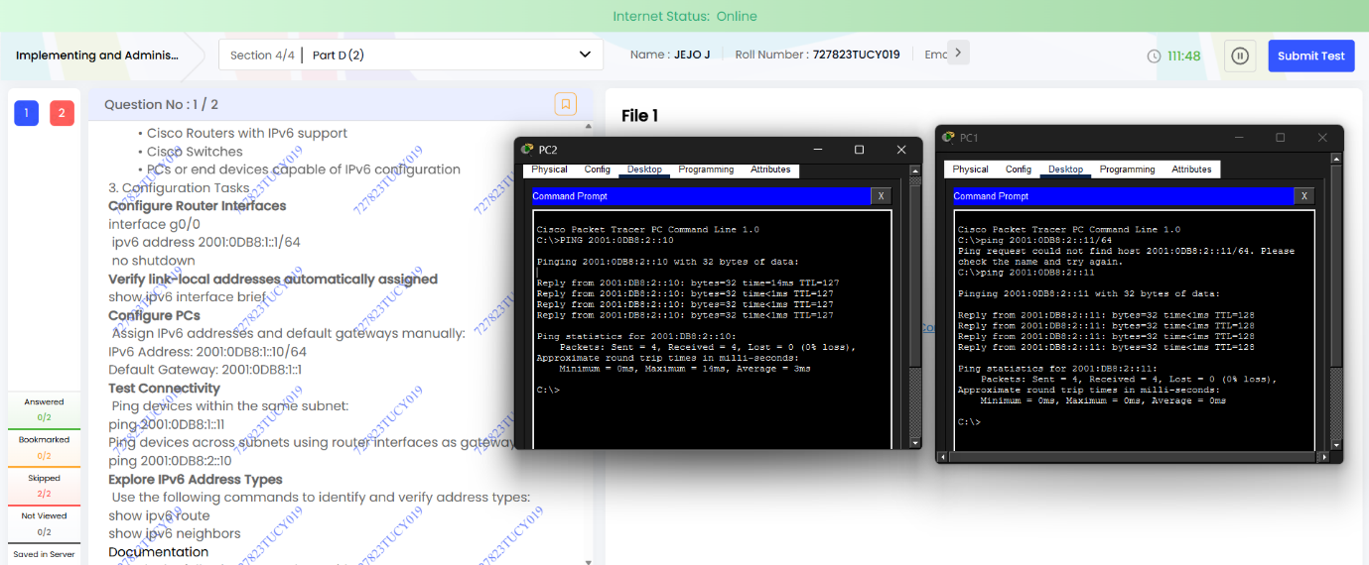

Name: Jejo J
Roll: 727823tucy019

